Self – Registration - Player
Topics Covered

Play Football Self Registration Portal 1
Create your Football Account 3
Claim Profiles 4
Self-Registration Portal 5
Self-Registration Steps – Registering Myself 6
6
STEP 1. - Select the Participant 7
I am registering myself 8
STEP 2.- Select Product 9
STEP 3.- Product Details 10
STEP 4.- Participant details 11
STEP 5. - Profile Photo 12
STEP 6. - International Transfer Clearnace 13
STEP 7. – Review Your Order 14
STEP 8. – Payment 15
VOUCHER/COUPONS 16
Online/ Offline 17
STEP 9. – Confirmation/ Perform another Registration 17
End of Registration 18

Play Football Self Registration Portal
As a Participant looking to register for the up-coming season, you will need to create a Football Account (https://www.ffa.com.au/football-account) If you already have a Football Account please sign in.
Any existing participants will have to ‘claim’ their account details, when a participant creates a Football Account the details used to create the account will be checked to see if there is any details from Myfootballclub that match.
If there is a match the participant will need to ‘claim’ those details as their own and proceed with their registration.

Create a Football account link >>> https://account.footballnetwork.com.au/register
Login to your Football account link >>> https://account.footballnetwork.com.au/
If you are required to set up other Club Administrators, please refer to the User Access Guide available through the ‘Help’ Portal located on the Play Football Website.
SUPPORT PORTAL -link
https://support.playfootball.com.au/support/home

Once you have your Football account then use the following link to register for Hornsby Heights Football Club: HHFC Registration Link

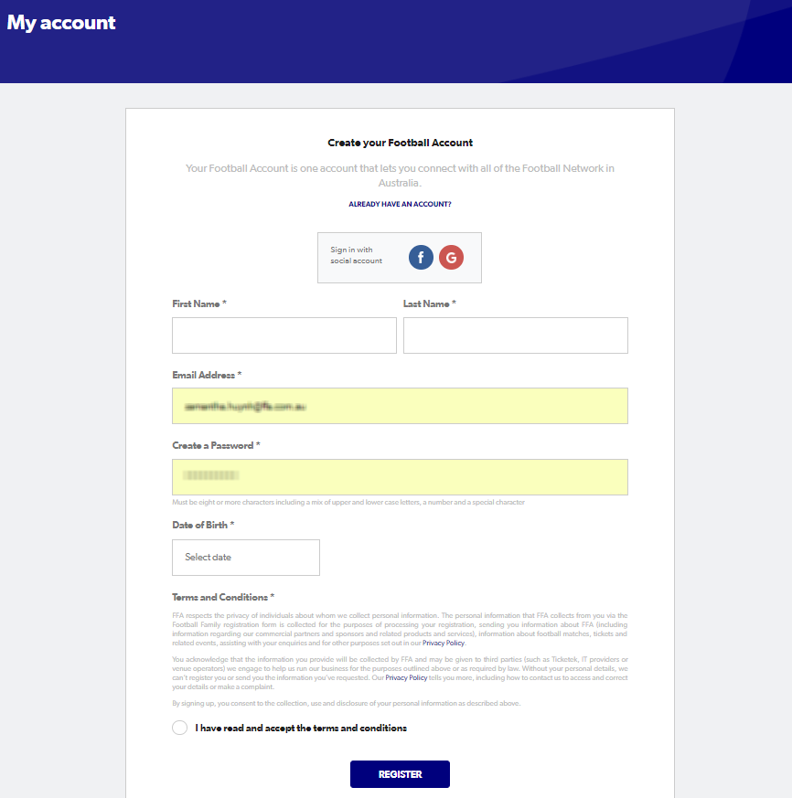
Create your Football Account

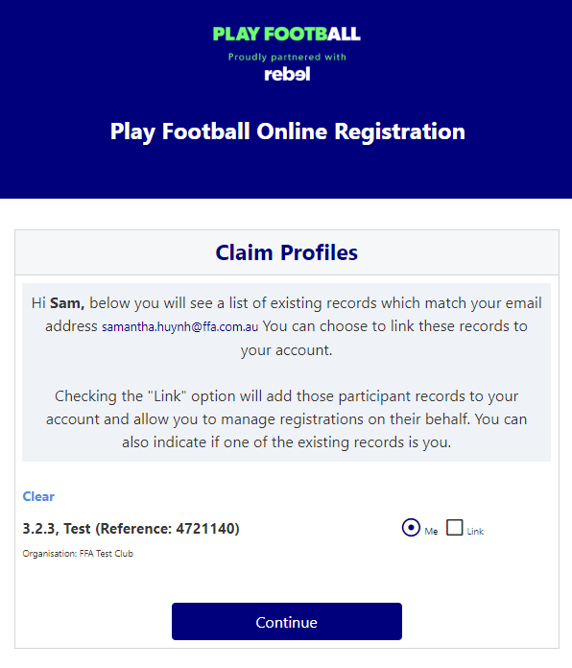
Claim Profiles

Self-Registration Portal
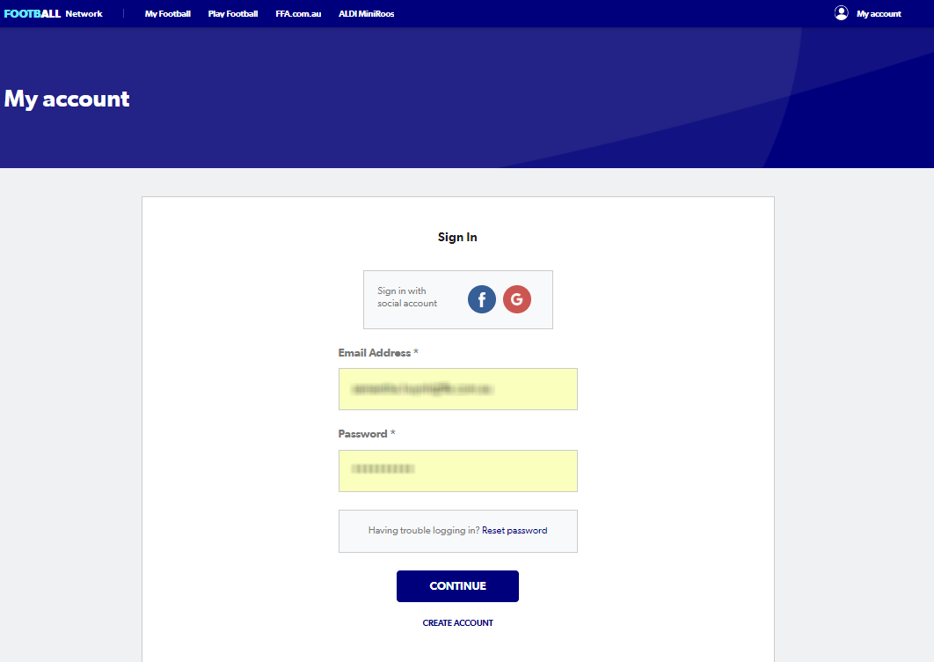

Self-Registration Steps – Registering Myself

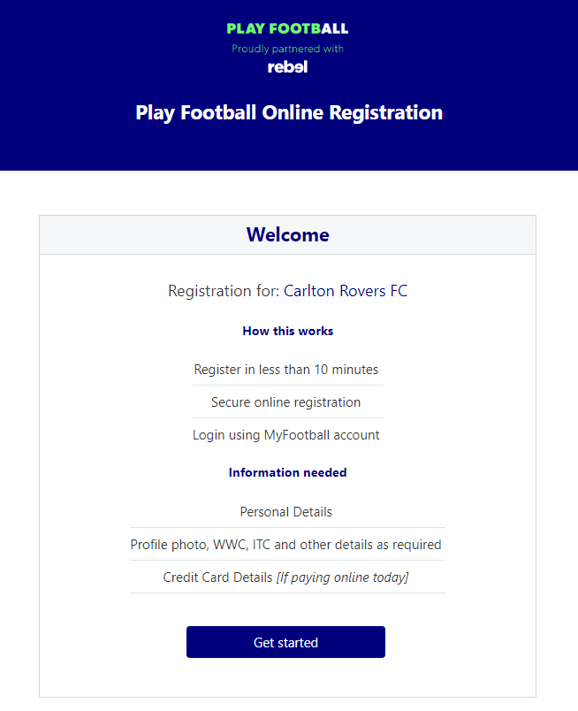
Navigate to the HHFC Registration Page.

STEP 1. - Select the Participant
- When you have created your Football account, please sign in and you will be presented with the Play Football Online Registration screen with your account details and any individuals you have linked to your account.
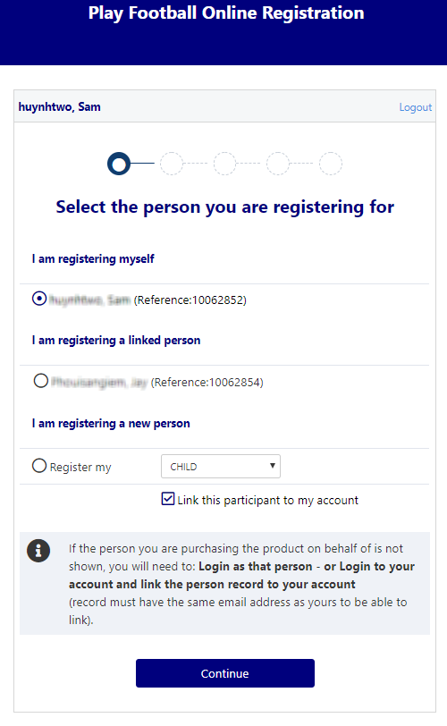
- If you are registering yourself select ’continue’

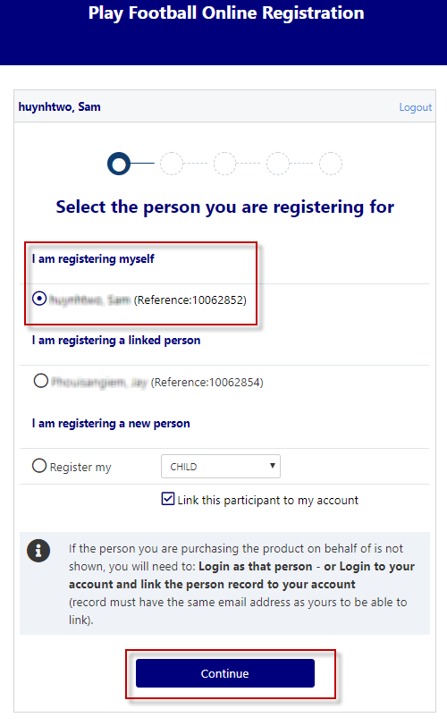
I am registering myself

- If you a registering a ‘Linked’ person select the participant and then ‘continue’

- If you are registering a new person select and continue.

STEP 2.- Select Product
- You will be shown all the ‘Products’ your clubs have on offer, select the product that you have been informed to select by your club. If you are UNSURE of which product to select speak with your club directly.
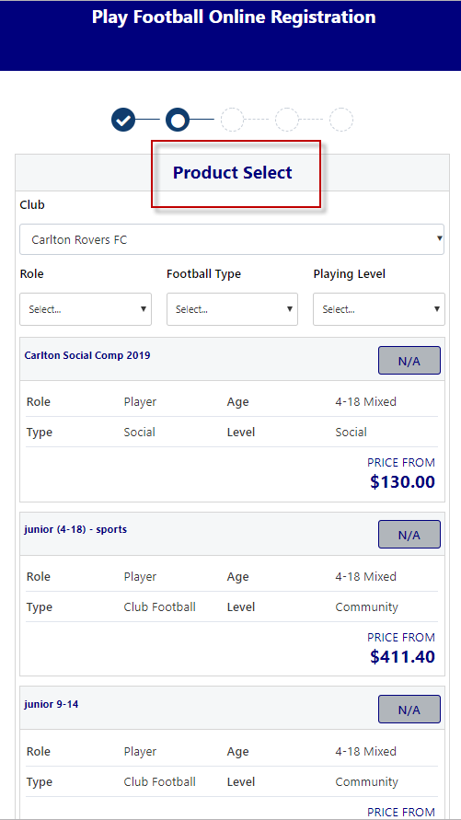
*Products – the package that you are purchasing. u/8 boys

STEP 3.- Product Details
- This step allows the participants to purchase ‘Optional products’ the club may offer.
- Participants can review the breakdown of the included FEES in their ‘Product’ selection.
- If an optional product is to be purchased select the product >select update cart = update the total

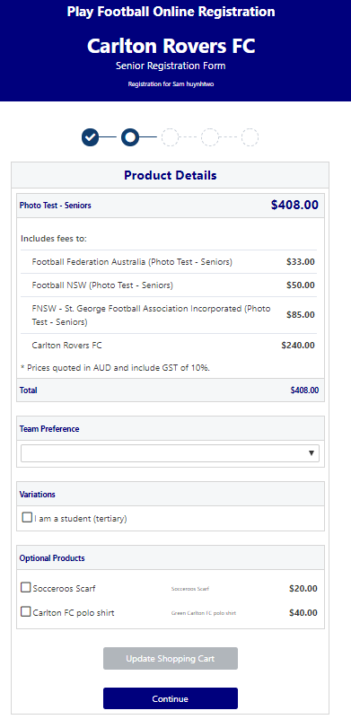

STEP 4.- Participant details
- Participants will be shown a details screen – please update all your details making sure all fields marked with * are completed.
- Additional questions and policy’s will also be displayed in this step
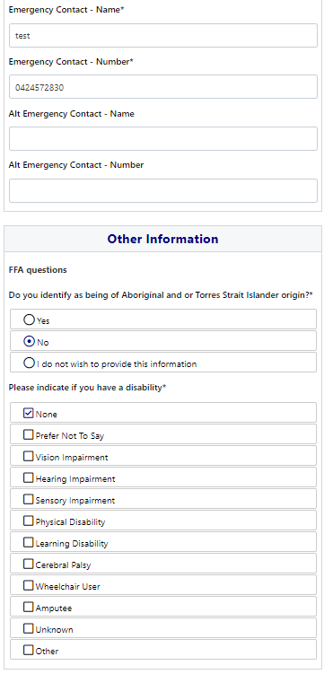
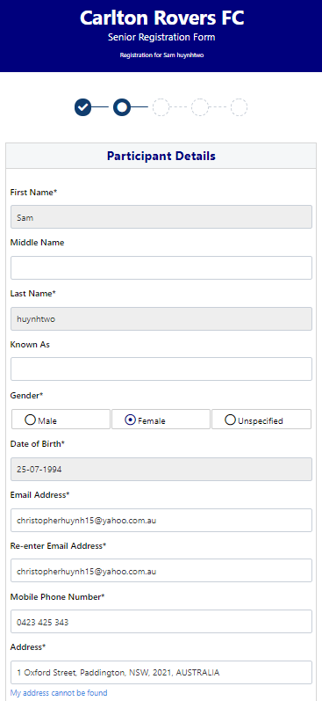

STEP 5. - Profile Photo
- Participants will need to upload a photo if this requirement has been set by your association
- The photo uploaded here will need to meet the image guidelines and will also appear on the participants Football account.
- Basic photo editing tools are also available

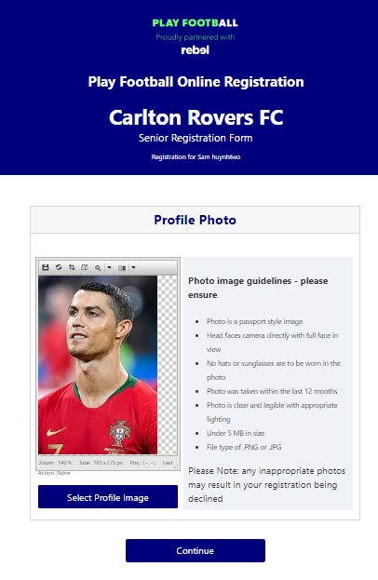

STEP 6. - International Transfer Clearnace

- Participants – Players will be presented with a question identifying if their last registration was with a Football club overseas.
- If your last registration was with an Overseas club you will need to select NO this will prompt the participant to continue processing an ITC request.
- ITC request will be sent when the participants registration is submitted.
- If no ITC is required select ‘ yes’ or ‘I have never registered to play football before’

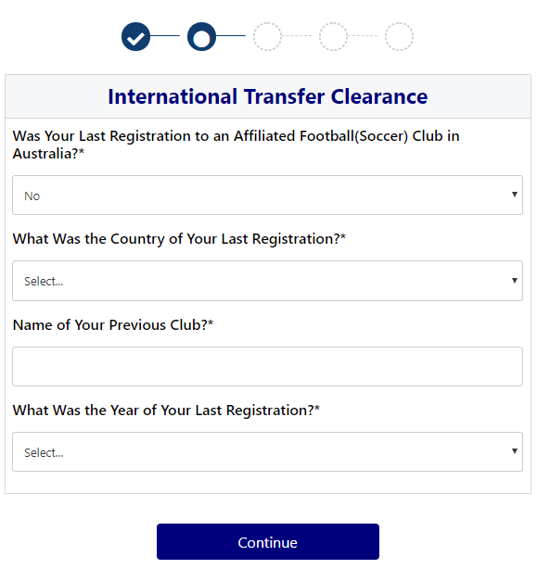
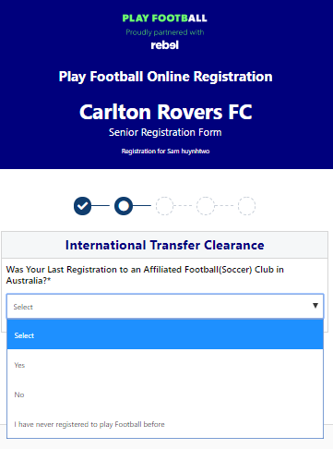

STEP 7. – Review Your Order
- Participants will have the chance to review their order at this step it is important participants review and edit.
- To edit any of the sections select ‘Modify’
- The Terms & Conditions will also appear at this step

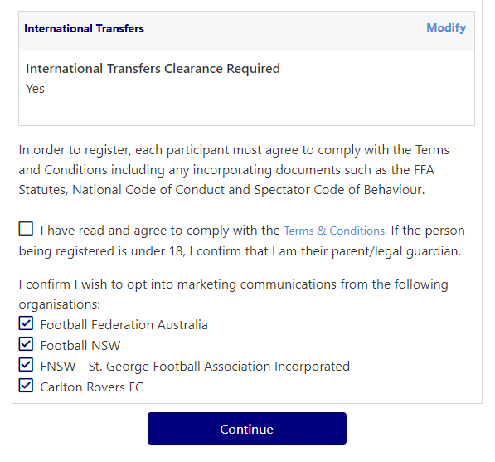
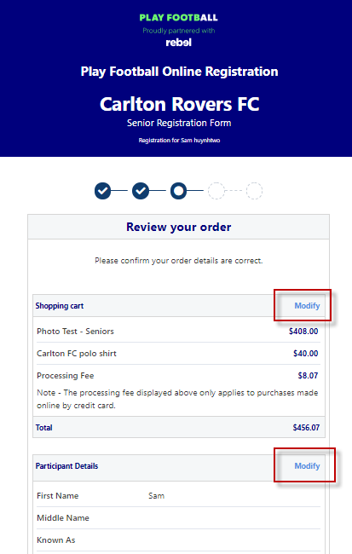

STEP 8. – Payment
- This step provides the participants the chance to review their product
- The product fee breakdown is displayed along with any discounts or additional products the participant has selected
- If the participant has selected an INCORRECT product, select one of the blue circles at the top of the page to go back in the process to select the correct product
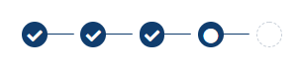
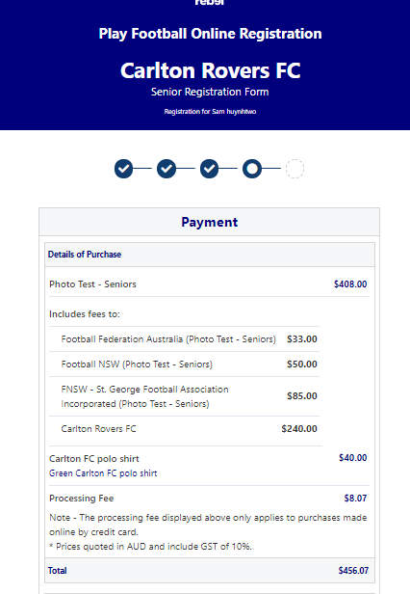
NOTE: If you are UNSURE of which product to select – contact your club directly to get the correct information in regard to your product selection

VOUCHER/COUPONS
- NSW particpants – who have a valid active kids voucher in their will need to enter the voucher details to redeem its value
- NSW/ACT/ Victoria/ Tasmania/ South Australia/ Western Australia/ Northern Territory/ Queensland particpants will need to speak with their Member Federations or Local Governments to see if sports voucher schemes are available in your state
- If you have obtained a sports voucher and you are from Victoria/ Tasmania/ South Australia/ Western Australia/ Northern Territory/ Queensland, PLEASE speak with your clubs directly to see how you can redeem your voucher
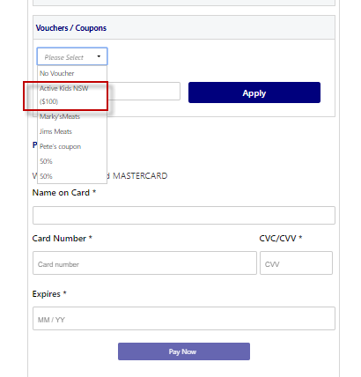

Online/ Offline
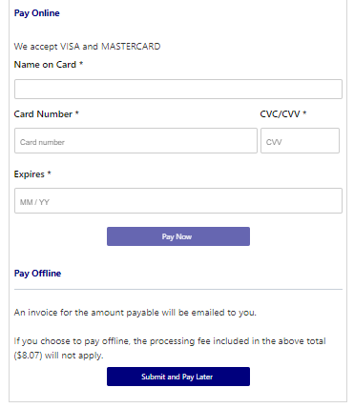
- Clubs set the payment options available for participants
- Online – Visa or Mastercard payments – Payments are to be made in FULL
- Offline – Clubs preference

NOTE: Payment options are set by Clubs – if there is an issue with payment options available to you, please speak with your club directly.

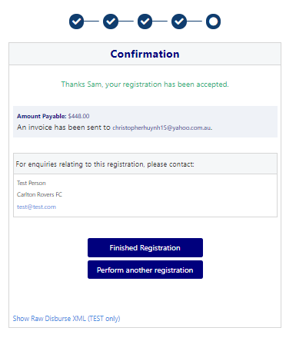
STEP 9. – Confirmation/ Perform another Registration

End of Registration
- Club Registrars will list the contact details for participants to use if they have any enquiries related to their Registration
- Selecting ‘Perform another Registration’ will take the participant back to step 1.
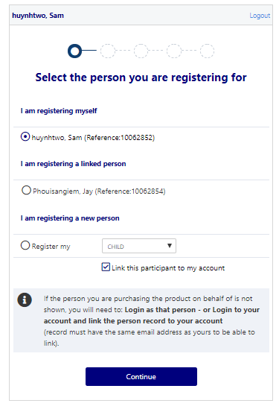
- I am registering a linked person, or I am registering a new person

